**SAP CAPM Using SQLite**

In this document, we describe how to implement and use a **getData** function within the SAP Cloud Application Programming Model (CAPM) using an SQLite database. This method is typically used in the local development phase when SQLite is used as the persistence layer for testing.

The **getData** method retrieves data from a specified entity using a SELECT operation and returns the result.

**Step by Step Implementation**

* **Step 1 : Define Data Model (Schema);**

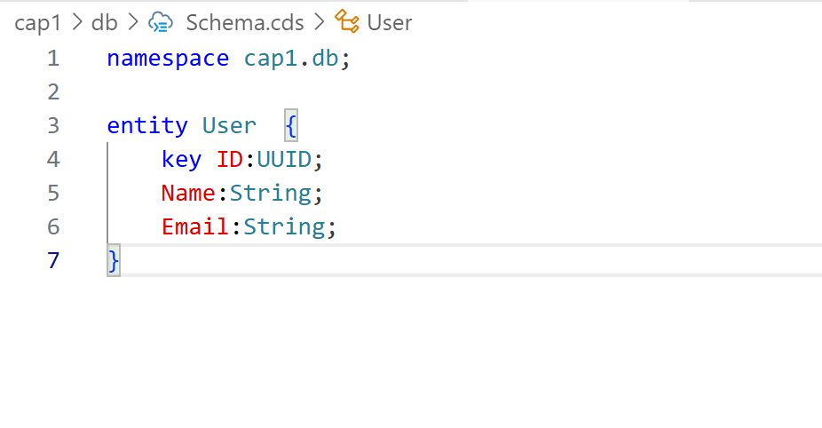

* **Step 2 : Define Service Model.**

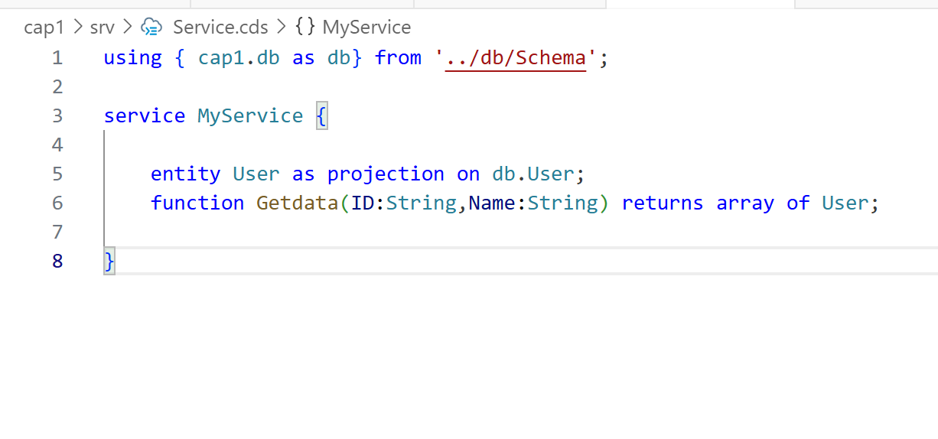

**Step 3 : Add Sample Data .**

Using command like **cds add data**

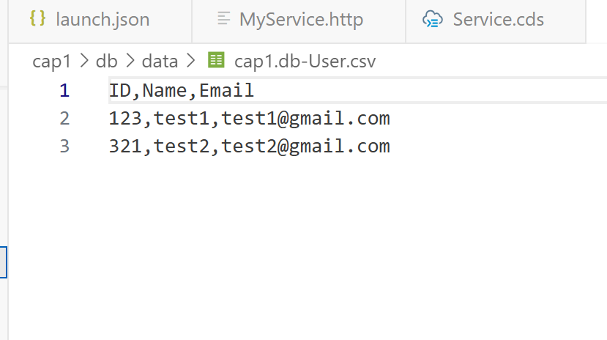

**Step 4 : Connect Sqlite Database.**

First used command **pwd** (for getting a path )



Second Add connection SQLTools and add last path( write a databaseName like cap1.db example)

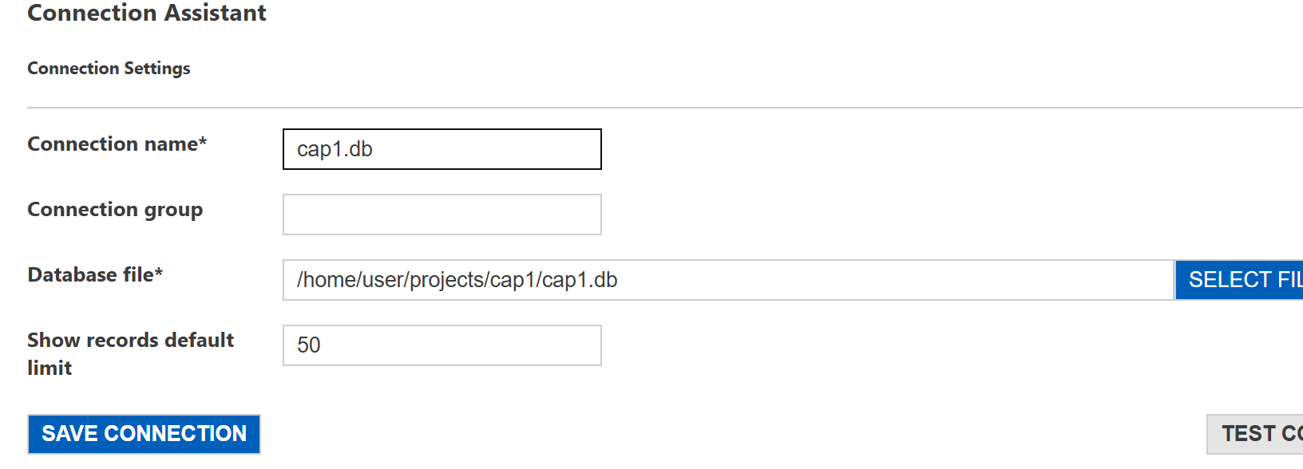

Third Save Connection.

After Show Connection Selection dropdown database Tables and Views.

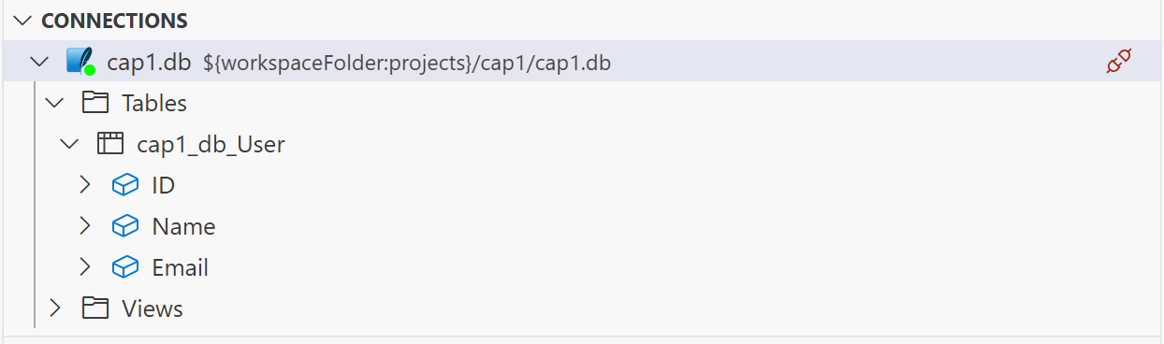

**Step 5 : Create Connection to the Database using package.json file .**

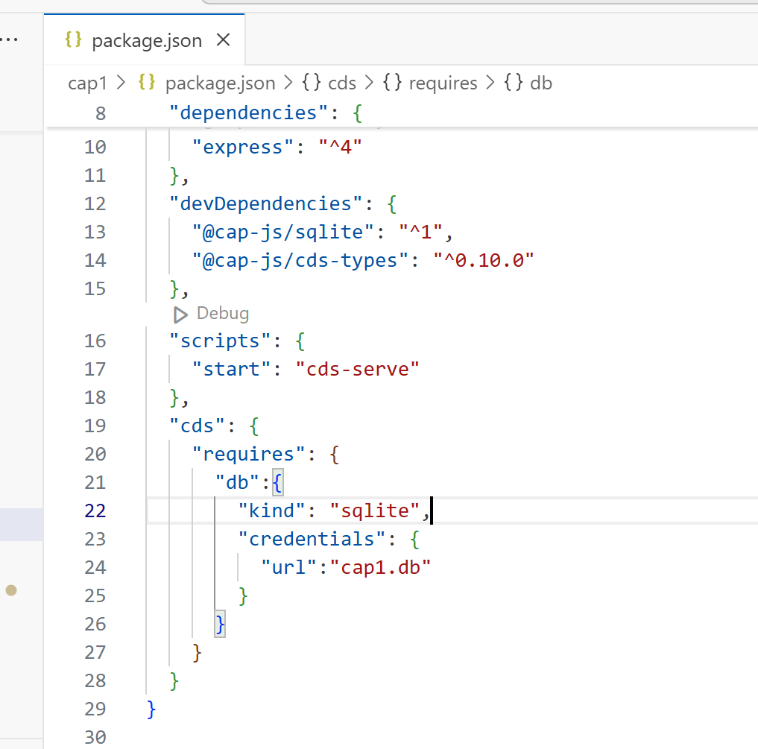

And using first npm install

After all is set then using a command like **cds deploy --to sqlite:cap1.db**

**Step 6 : Implement Custom Logic**

First Create a srv/Service.js file ( extension .js)

First way.

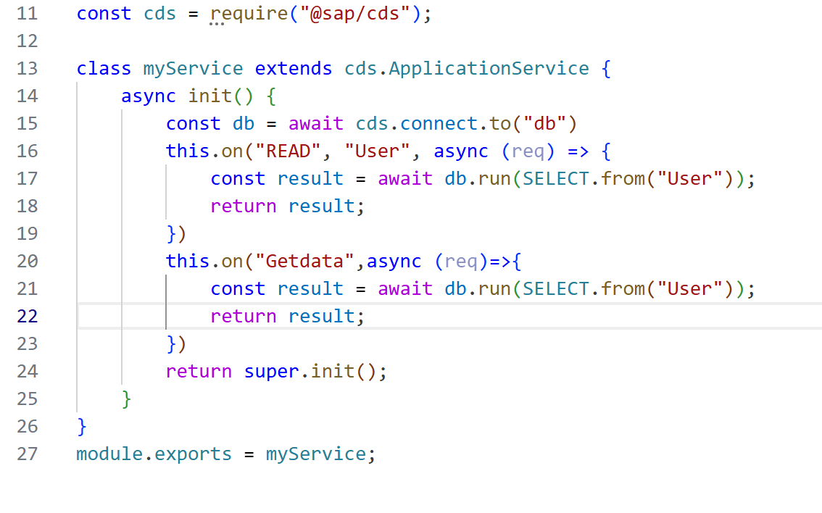

**Step 7 : Run the Application using a command like cds watch or cds run.**

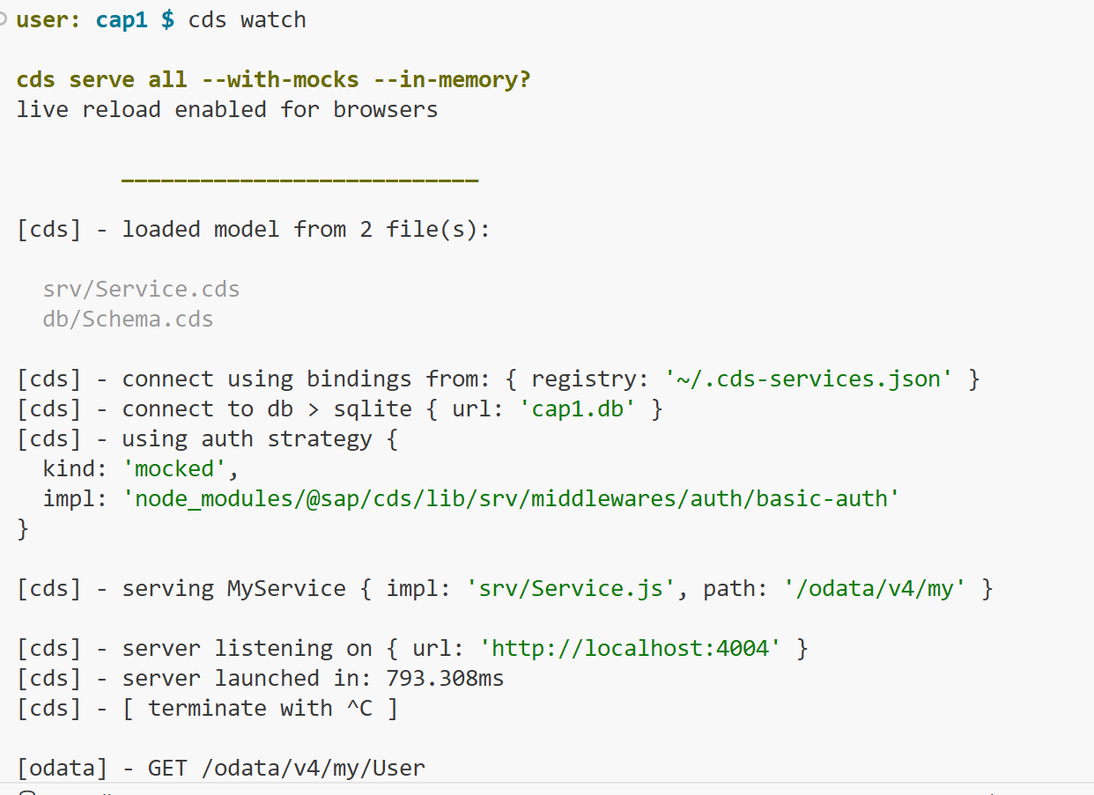

**After calling a function method (Getdata) like.**



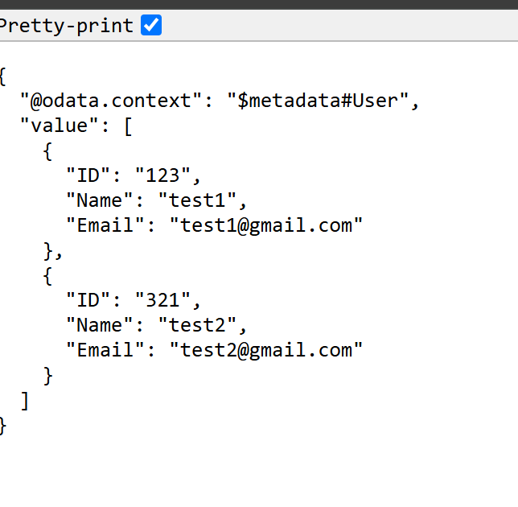

**----------------------------------------Completed-------------------------------------**